# 1. On the basis of chapter 3 in ‘Veje til et nyt sprog – teorier om sprogtilegnelse’ write about, describe and discuss the three presented hypotheses on language acquisition on pp. 48-55 Input, output og interaction: Tre hypoteser om sprogtilegnelse.

**Rod Ellis** states that the underlying basis of language acquisition is through some sort of dialogue with other people. The learner does not necessarily speak face to face with others, but he/she has to have heard or read what someone has said or written in order to acquire language.

The learner receives input and produces the output himself. Throughout this process the learner deduces rules of the target language and achieves knowledge on the target language and how the language should be spoken.

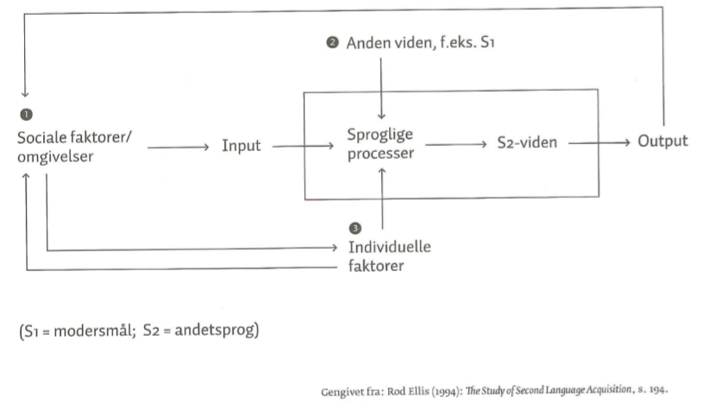

**THE INPUT HYPOTHESIS BY STEPHEN KRASHEN**

Krashen states that the underlying basis of language acquisition is that people learn language by receiving a comprehensible input. People learn when they understand what they read or hear. Krashen states that the learner learns in a specific order (the mentalists states this too).

The input is best learned, or input becomes intake, if it is “i+1”. The “i” is the level of the learner’s interlanguage. And the “1” is the next step in the specific/natural order of acquiring the target language.

* This means that the input has to be just a little bit more challenging and harder to understand for the learner
* Comprehensible input +1

The critique is that the input hypothesis/ “i+1” is rather imprecise and that it is a bit unclear how to define what is “I” and “1”. 🡪 The teacher has to know the pupil very well in order to work with this hypothesis usefully.

**THE INTERACTION HYPOTHESIS BY MICHAEL LONG**

This theory states that comprehensible input is crucial for the learner to acquire the target language. But at the same time, he states that the most efficient way of finding out what is comprehensible input to the learner is “to negotiate meaning”. This negotiation of meaning is what happens when a language user shows his conversational partner/interlocutor that he does not understand what is being said. Then the interlocutor has the opportunity to adjust his language and make it comprehensible.

* Comparing it with Krashen’s theory, this would be like aiming at the “i+1”.

It is not clear whether or not the negotiation of meaning has an impact on the acquisition, but Long and other scientists point out that the negotiation has importance in several ways.

* The learner has time for processing the input – making it ‘intake’
* The interlocutor’s adjustment scaffolds the learning process

The teacher’s lessons have to be communicative when working with the interaction hypothesis. The students have to be put in situations where they are able to ‘negotiate meaning’.

**THE OUTOUT HYPETHESIS PÅ MERRIL SWAIN**

There is some disagreement in the scientific field on whether the output (what the learner says and writes) has an impact in language acquisition or not. E.g. Krashen states that the input is the generator of language acquisition and holds on to the statement that the output is a result of the acquisition from the input.

Merrill Swain disagrees with Krashen. She argues that the output is rather important. It does not mean that the learner automatically learns the language when producing output, but she argues that the output in the target language can lead to acquisition if the learner is being pushed. A strained (pushed) output production means that the learner has to produce language and express language above his current level and linguistic skills.

Swain states that language learning occurs through output because:

* Noticing function: The learner gets aware of the ‘gap’ between what he wants to express and what he is currently capable of expressing 🡪 “noticing the gap”
* Hypothesis function: The learner can ‘test’ his hypotheses on the target language. In an interaction with an interlocutor (e.g. a native speaker or a more competent language learner) the learner gets his hypothesis tested by receiving a response (confirming or disconfirming) from the interlocutor.
* When producing output, the learner has to reflect on the language. When producing output, the learner has an understanding/comprehension of the content that he has to ‘form’.

The pressured/strained/pushed learning forces the learner to reflect on the form of the target language.

## Supplementary optional questions: Can you relate to this triad: Input, output and interaction, represented by Krashen, Long and Swain – does it make sense to you? Would you aim at having all phases represented in your teaching – and if so, how?

I can definitely get behind all of the hypotheses. But I think that I agree with the Merrill Swain and Michael Long more than Krashen. It makes sense to me that Long argues that learning and acquiring the TL happens when interacting with an interlocutor. It agrees with my communicative view on language learning. I like Merrill Swain output hypothesis because it makes the pupils notice the gap between their interlanguage and the target language and that it also contains a communicative view on language learning when the learner can ‘test’ his hypotheses when creating output like Long’s “negotiation of meaning”. But as Krashen states, the input is very important too as I, as a teacher, is to deliver such input.

I would aim at giving the students tasks that make them interact and create both oral and written output.

# 2. On the basis of chapter 4 in ‘Veje til et nyt sprog – teorier om sprogtilegnelse’ write about, describe and discuss the depicted learning view on pp. 56-65 Den lingvistiske tilgang: Det ligger i sproget.

The linguistic approach focuses on language. The linguistic approach states that it is possible to look at language isolated from its communicative context. The linguistic approach contains three areas: contrastive linguistics, linguistic universals and the theory of markedness.

**CONTRASTIVE LINGUISTICS**

The contrastive analysis-hypothesis states that there is a linguistic distance or gap between the mother tongue and the target language. This ‘distance’ is a crucial factor in defining how difficult it will be to learn the target language.

The renaissance of the contrastive analysis is a modified version of the old contrastive analysis. The new contrastive analysis aligns with interlanguage theory.

* The learner uses his L1 as a basis, and from that the learner produces hypotheses.
* The teacher should be aware of this in order to understand why and how the learner creates specific hypotheses

The L1 has an impact on how the target language will be pronounced. If the learner has a sound from the L1 that is close to the sound in target language, the learner is prone to replace the new sound with the parallel sound without noticing.

**LINGUISTIC UNIVERSALS**

The linguistic studies on universals is interested in finding common characteristics in different languages or groups of languages. This sort of characterization/classification is described through the studies og typology and universals.

* A typological determination of the L1 and the target language can be used in the contrastive approach on language acquisition
* Chomsky’s universal grammar can help explain how common characteristics in the L1 and the L2 makes it easier to learn the target language.

**THEORY OF MARKEDNESS**

According to Chomsky every language has both characteristics/traits determined by the universal grammar (being the core of the language) and characteristics borrowed elsewhere.

* Characteristics from the universal grammar/the core of the language are called **unmarked**
* Characteristics from elsewhere/the periphery of the language are called **marked**

The unmarked is the most frequent and widespread in the languages of the world whereas the marked is more special/exotic.

This means that the **unmarked** structures should be easier to acquire because of the help of universal grammar. The unmarked is acquired first, then the marked.

The theory of markedness applies to both grammar and vocabulary.

The theory of markedness explains the convergence/agreement between interlanguage and actual language.

It is possible that the unmarked structures are acquired before the marked, not because they are unmarked but, but because they are more common and frequent.

## Supplementary optional questions: How could the linguistic approach influence your way of teaching? Which materials and exercises would you like to use?

It would probably influence my way of teaching as I would be aware of how linguistic universals influence the production of hypotheses and how the L1 affects the pronunciation of the target language.

# 3. On the basis of chapter 5 in ‘Veje til et nyt sprog – teorier om sprogtilegnelse’ write about, describe and discuss the defined learning view on pp. 66-83 Den kognitive tilgang: Det foregår i hovedet

The cognitive approach seeks to explain the processes in the brain of the learner when he is to acquire a language. What is happening in between input and output, and what part does memory play?

**COGNITIVE THEORY**

The theory sees the learner as an active creator of grammar. The theory presumes that the learner builds up linguistic knowledge by creating hypotheses about linguistic patterns and rules on the basis of what they already know. The learner tests the hypotheses in its surroundings, and they are either confirmed or disconfirmed. The underlying basis of language acquisition in cognitive theory is both INPUT, OUTPUT and INTERACTION.

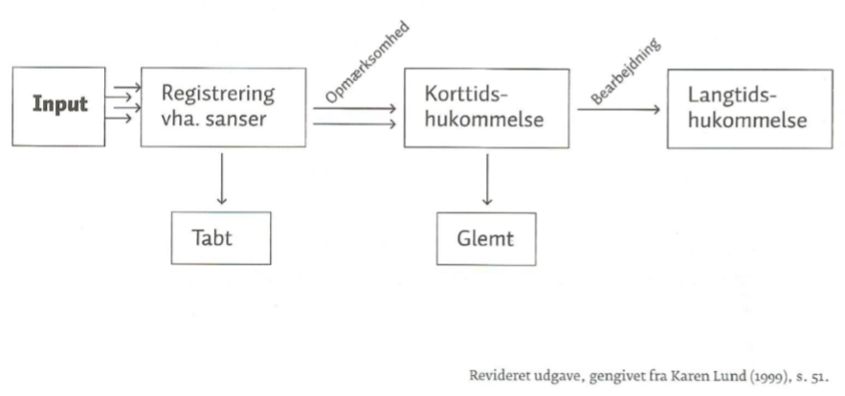

The short-term memory (working memory) processes data from the senses. The long-term memory processes the data coming from the short-term memory.

A linguistic element is only acquired when it is stored in the long-term memory. This is why it is interesting to have a look on how the linguistic elements gets processed by the short-term memory and the long-term memory.

**Awareness: is language acquisition conscious or unconscious?**

Krashen is one of the theorists who argues that language acquisition is an unconscious action. Krashen distinguishes between *acquisition* and *learning.*

* Acquisition happens naturally in relations with others. Focus is on meaning not the form. The most important part of language acquisition.
* Learning is not as natural. The focus is on form.

The most extreme about this theory is that he insists that there is a wall between acquisition and learning.

The most important thing is the acquisition. If the learner is aware of the meaning in the comprehensible input the learner will then acquire the form – to acquire the form is a ‘side effect’ of comprehending/understanding the meaning.

Richard Smith disagrees with Krashen. He argues that the learner has to be attentive to the form of the language in order to acquire it. Schmidt states that the learner has to be aware of three different factors which influences language acquisition.

* Consciousness in form of intention: Focusses on the difference between the situations where learning happens intended or unintended or if it is a side effect of another activity.
* Consciousness in form of knowledge: Explicit or implicit knowledge. Is the pupil able to explain his knowledge?
* Consciousness in form of attention: The level of attention explains if the input is transformed into ‘intake’.

Furthermore, Schmidt *divides the attention* into three different degrees

Sensing, noticing and comprehension

The ‘noticing’ is the level of attention needed to transform input into ‘intake’.

The theory of consciousness and attention is a clarification of the input hypothesis.

The input is a crucial factor for language acquisition and the level of attention towards the linguistic elements determines if the input becomes ‘intake’.

**The level of involvement – the involvement load hypothesis**

Laufer and Hulstijn states that the learner has to be involved in order to acquire. They conclude that the most important factor is how involved the learner is in the task/activity.

The load of involvement is considered through the learner’s:

* Need
* Search
* Evaluation

Laufer and Hulstijn’s research shows that the bigger the load of involvement, the better requisites for language acquisition.

**PROCESSES AND STRATEGIES: THE PROCESSING BRAIN**

The acquisition is a result of the brain processing input.

Manfred Pienemann: The more difficult a rule is, the later it is acquired by the learner.

* The theory om processability
* It is the cognitive limitations in the learner which make the learner acquire language in specific stages.

TWO different factors which determines how many cognitive resources the linguistic rule requires

* How hard it is to identify the linguistic rule/element
* How hard it is to analyze the grammatical rule in order to use it

Anne Holmen and Karen Lund states that the order of acquisition is determined by the function of the linguistic element and its function in the language.

* The learner focuses on the elements which carries a lot of meaning
* It is a communicative view on language acquisition

**Good habits when learning a language**

O’Malley and Chamot says that the learner can use learning strategies in order to comprehend and acquire language.

* Cognitive strategies
* Metacognitive strategies
* Social/affective strategies

Oxford classifies the strategies differently.

* Direct strategies

Memorization strategies

Cognitive strategies

**Communication – and compensation strategies**

* Indirect strategies

Metacognitive strategies

Affective strategies

Social strategies

# 4. On the basis of chapter 6 in ‘Veje til et nyt sprog – teorier om sprogtilegnelse’ write about, describe and discuss the described learning view on pp. 84-95 kap. 6 Den sociale tilgang: Det sker mellem os.

The social approach puts the pupil as a social individual who learns language when interacting with others.

L. Vygotsky: the zone of proximal development

J. Bruner: the concept of scaffolding.

* Linguistic scaffolding helps language acquisition

Richard Donato: studied how scaffolding can help learners acquire grammatical elements in the target language.

* Collective scaffolding: Learning in groups. Three ways

1. The group of students put together the ‘parts’ missing in order to create a ‘whole’.
2. The group of students notice deviations in relations to their own idea of the right solution
3. They curb their frustrations by trusting the collective resources.

The conclusion is that collective scaffolding can lead to individual language acquisition.

## Supplementary optional questions: What does it take in terms of the ‘climate and atmosphere of the class’ to work according to the social approach? Can you foresee any challenges?

I would like to work with collective scaffolding as it would be good for the individual acquisition but also the climate of the class cf. Richard Donato’s “c”.